OOP week 1

Minutes

**Date**: 13/03/2020

**Time**: 12:15

**Chairperson** :

# In attendance

Daniel Kraska

Jordan Goodfall

Jordan Smart

# Apologies

Natalie Duff

# Discussion of ideas for the project

The decided not to create a game and focus on creating a data management/acquisition system was made. Such system is ideal as it makes use of classes to create objects and can also make use of reading and writing data to and from external files.

The following ideas were Proposed:

# Initial discussion of specification for the project

Create a data management system for a supermarket. The system should allow for adding, editing as well as deleting products and store specific information depending on the type of the product. In addition to this the system should generate both sales and inventory reports and write them to external text files. Lastly the system has to keep track of stock levels and automatically generate an order once an item falls below a set reorder level.

# Initial discussion of breakdown project into classes

The initial breakdown of the project into classes was done using a class table chart to better visualise the system in question.

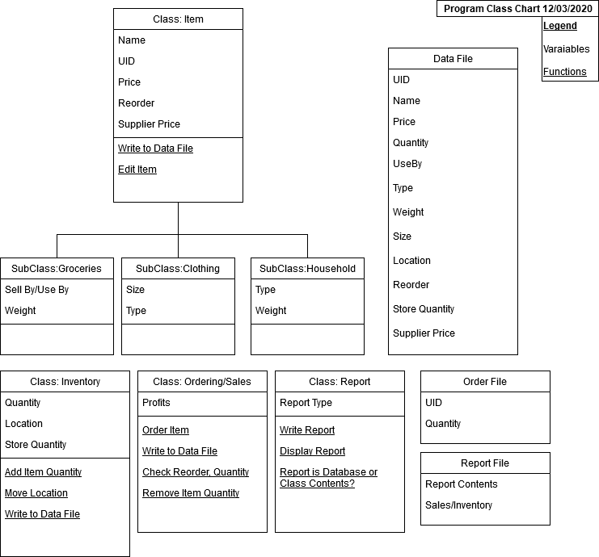

# Allocation of classes to programmers

|  |  |
| --- | --- |
| Daniel Kraska | Item Class |
| James Goodall | Inventory Class |
| Jordan Smart | Report |
| Natalie Duff |  |

# Initial discussion of service functions required for interoperability of classes

See class chart for function names.

# Next meeting

20/03/2020 09:15, Location

Motion to adjourn was made at 21:00 and was passed unanimously.